https://stackoverflow.com/questions/42683438/qt-5-8-sql-connection-errorqmysql-driver-not-loaded-on-windows-10#:~:text=When%20QMYSQL%20is%20available%20but%20not%20loaded%2C%20you,project%20kit%2032%20bit%20use%20MySql%2032%20bit.

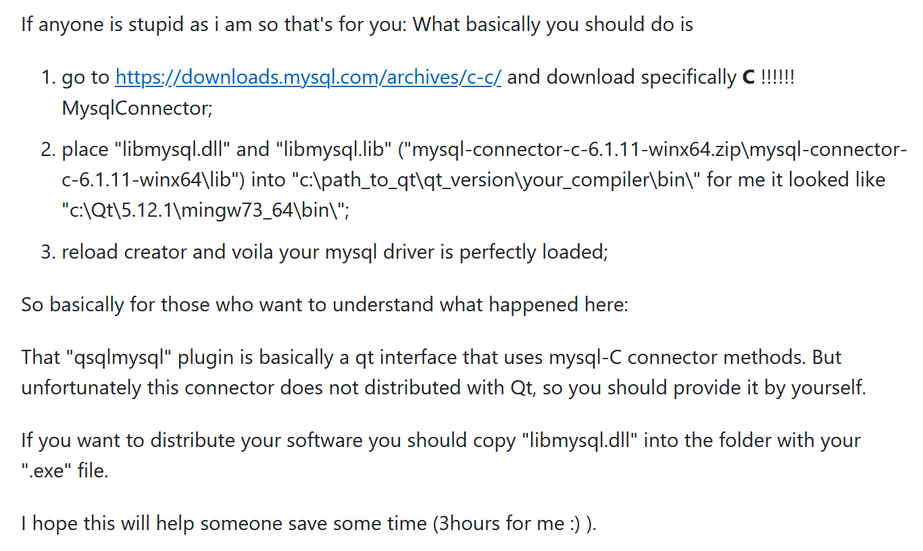

1.download my sql connector:

https://downloads.mysql.com/archives/c-c/

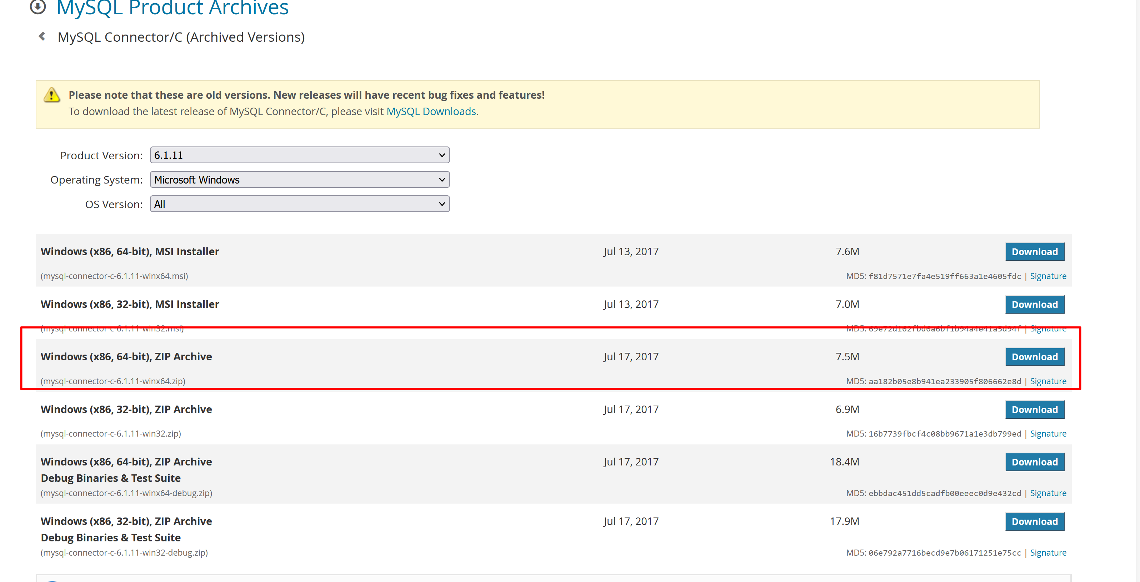

2.copy place "libmysql.dll" and "libmysql.lib" ("mysql-connector-c-6.1.11-winx64.zip\mysql-connector-c-6.1.11-winx64\lib") into "c:\path_to_qt\qt_version\your_compiler\bin\" for me it looked like "c:\Qt\5.12.1\mingw73_64\bin\";

or set path to to access these 2 files.

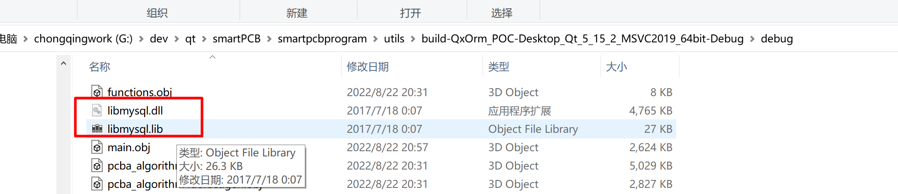

NOTE: in my case

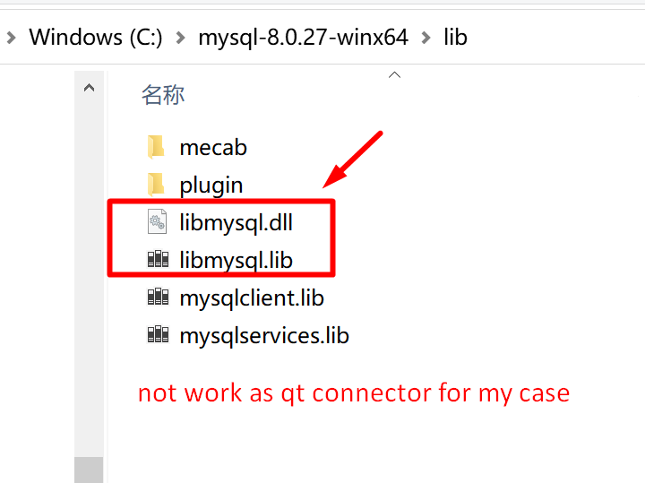

-----------------降低mysql版本解决方案---------------

一、问题描述

Qt连接MySQL提示：

"SSL connection error: unknown error number QMYSQL: Unable to connect"；

二、解决办法：换低版本的MySQL

开始用的“8.0.28.0”版本的MySQL出现以上提示，

卸载8.0版本，安装低版本的“5.7.18.0”MySQL问题解决

————————————————

版权声明：本文为CSDN博主「怎么追摩羯座」的原创文章，遵循CC 4.0 BY-SA版权协议，转载请附上原文出处链接及本声明。

原文链接：https://blog.csdn.net/Viciower/article/details/125224445